CSS

=—

HTML –

**HOME PAGE DESIGN**

<!DOCTYPE html>

<html lang="en">

<head>

    <meta charset="UTF-8">

    <meta http-equiv="X-UA-Compatible" content="IE=edge">

    <meta name="viewport" content="width=device-width, initial-scale=1.0">

    <title>Document</title>

    <link rel="stylesheet" href="style3.css">

    <link rel="preconnect" href="https://fonts.googleapis.com">

<link rel="preconnect" href="https://fonts.gstatic.com" crossorigin>

<link href="https://fonts.googleapis.com/css2?family=Fredericka+the+Great&display=swap" rel="stylesheet">

</head>

<body>

<header class="header">

    <div class="left">

        <img src="logo-removebg-preview.png" height="70" width="300">

    </div>

    <div class="mid">

        <ul class="navbar">

            <li><a href="file:///E:/html/we_bsite.html#">HOME</a></li>

            <li><a href="https://bubhopal.mponline.gov.in/Portal/Services/BARKATULLAH/STUDENT_MGMT_SYS/Create_login.aspx">STUDENT</a></li>

            <li><a href="file:///E:/html/faculty.html">FACULTY & STAFF</a></li>

            <li><a href="file:///E:/html/alumini.html">ALUMNI</a></li>

        </ul>

    </div>

    <div class="right">

        <button class="btn"><a href ="file:///E:/html/login_page.html" target="_blank"></ahref>LOGIN</a></button>

        <input type="text" placeholder="Search.." class="btn">

    </div>

</header>

<div class="container">

    <ul class="navbar1" id="menuu">

        <li><a href="#">Notes</a></li>

            <li><a href="file:///E:/html/pyq.html">PYQs</a></li>

            <li><a href="https://bubhopal.mponline.gov.in/Portal/Services/BARKATULLAH/Counterbase/Result/VeiwResult.aspx">Result</a></li>

            <li><a href="https://www.instagram.com/bubhopalstudents/?hl=en">Events</a></li>

            <li><a href="#">Apply</a></li>

            <li><a href="https://www.google.com/search?q=news+buit+bhopal&rlz=1C1RLNS_enIN1007IN1007&source=lnms&tbm=nws&sa=X&ved=2ahUKEwjIo_n2-pf4AhUNUGwGHSmAA68Q_AUoAXoECAEQAw&biw=1366&bih=625&dpr=1">News</a></li>

            <li><a href="https://www.shiksha.com/university/barkatullah-university-bu-bhopal-25770/courses/be-btech-bc">Fees</a></li>

    </ul>

</div>

<div class="main_container">

<div class="main">

    <p id="first">Welcome to UIT BU,BHOPAL.</p>

    <p id="second">Become the author of your own powerful story....<br>Any successful career starts with good education.Together with <br>us you will have deeper knowledge of the specific subjects that will <br>be especially useful for you whole climbing the career ladder.</p>

</div>

</div>

<div class="container2">

    <div class="box">

<p id="para1">ABOUT</p>

     <p id="third">'Barkatullah University , formly known as Bhopal University, was established in 1970 in the capital city of Madhya Pradesh and rechristened in 1988 as Barkatullah Vishwavidhyalaya in the living memory of the great freedom fighter Prof. Barkatullah who belong to Bhopal. The University has been acccredited 'B' grade by NAAC in 2015. University Campus covering an area of approx. 400 acres of land is located along Hoshangabad highway at a distance of about 3 km from Habibganj Railway Station.</p>

    </div>

    <div class="box">

        <p id="para2">COURSES WE OFFER...</p>

        <ul id="list1">

            <li>B.E. in Computer Science & Engineering</li><br>

            <li>B.Tech. in Information Technology</li><br>

            <li>B.Tech. in Civil Engineering</li><br>

            <li>B.E. in Mechanical Engineering</li><br>

            <li>B.Tech. in Electronics & Communication Engineering</li><br>

        </ul>

    </div>

    <div class="box">

        <p id="para3">FACILITIES AVAILABLE...</p>

        <ul id="list2">

            <li>Beautiful Campus</li>

            <li>Air Conditioned Campus</li>

            <li>Well Equiped Classrooms</li>

            <li>Library</li>

            <li>Hostel Available</li>

            <li>Sports Events</li>

            <li>Technical Events</li>

            <li>Scholarship Available</li>

            <li>Placement Cell</li>

            <li>Incubation Center</li>

            <li>Recruting Comapaines</li>

            <li>Average Package Offered</li>

        </ul>

    </div>

</div>

<section class="footer">

    <div class="social">

        <a href ="https://www.facebook.com/BarkatullahUniversity/" target="_blank"><img src="images-removebg-preview.png" width="80" height="50"></i></a>

        <a href="https://www.instagram.com/bubhopalstudents/?hl=en" target="_blank"><img src="instagram-icon-png-transparent-instagram-icon-images-884866-removebg-preview.png" width="80" height="60"></a>

        <a href="https://www.youtube.com/" target="_blank"><img src="twitter-icon-transparent-11549680383mmzgiol88v-removebg-preview.png" width="60" height="55"></a>

    </div>

    <div class="social2">

        for more details contact <a href="#"> bubhopal123@gmail.com

            </a>

            </div>

</section>

</body>

</html>

CSS

=—

*{

    box-sizing: border-box;

}

body{

    padding: 0;

margin: 0;

background : url(Purple-polar-lights-abstract-background-vector55.jpg);

background-repeat: no-repeat;

background-size: cover;

color: aliceblue;

}

.header{

    top: 0;

    left: 0;

    width: 100%;

    height: 100px;

    padding: 10px 10px;

    box-sizing: border-box;

    background: rgba(0, 0, 0,0.6);

    border-bottom: 1px solid black;

    position: sticky;

}

.left{

    display: inline-block;

    position: absolute;

    left: 0px;

    top: 20px;

}

.mid{

    display: block;

    width: 60%;

    margin: 15px auto;

}

.right{

    position:absolute;

    right: 34px;

    top:30px;

    display: inline-block;

}

.navbar{

    display: inline-block;

}

.navbar ul{

    list-style: none;

    float: right;

    margin: 0;

    padding: 0;

    display: flex;

}

.navbar li{

    display: inline-block;

    font-size: 25px;

}

.navbar li a{

    color: white;

    text-decoration: none;

    padding: 34px 23px;

}

.navbar ul li a:hover{

    background: rgba(0, 0, 0, 0.7);

    border-radius: 6px;

    cursor: pointer;

}

.navbar li a:hover , .navbar li a:active{

    text-decoration: underline;

    color: grey;

}

.btn{

    font-family: 'Lucida Sans', 'Lucida Sans Regular', 'Lucida Grande', 'Lucida Sans Unicode', Geneva, Verdana, sans-serif;

    margin: 0px 0px;

    background-color: black;

    color: white;

    padding: 10px 10px;

    border: 2px solid gray;

    border-radius: 10px;

    font-size: 15px;

    cursor: pointer;

}

.btn:hover{

    background-color: rgb(31,30, 30);

}

.container{

    top: 0;

    left: 0;

    width: 100%;

    height: 50px;

    /*padding: 0px 0px;*/

    padding-bottom: 10px;

    box-sizing: border-box;

    background: rgba(0, 0, 0,0.6);

    border: 1px solid black;

    margin-top: 5px;

}

#menuu{

    display: block;

    width: 60%;

    margin: 15px auto;

}

.navbar1{

    display: inline-block;

}

.navbar1 ul{

    list-style: none;

    float: right;

    margin: 0;

    padding: 0;

    display: flex;

}

.navbar1 li{

    display: inline-block;

    font-size: 25px;

}

.navbar1 li a{

    color: rgb(248, 152, 197);

    text-decoration: none;

    padding: 34px 23px;

}

.navbar1 ul li a:hover{

    background: rgba(0, 0, 0, 0.7);

    border-radius: 6px;

    cursor: pointer;

}

.navbar1 li a:hover , .navbar1 li a:active{

    text-decoration: underline;

    color: grey;

}

.main{

    padding: 15px 15px;

    margin-left: 70px;

    margin-top:40px;

    color: black;

    height:300px;

    background-color: rgba(116, 150, 202, 0.63)

}

.main_container{

    display:flex;

    background: url(300418_full_width_banner.jpg);

    background-repeat: no-repeat;

    background-size: cover;

    height: 400px;

}

#first{

    font-family:algerian;

    font-size: 40px;

    font-weight: bold;

}

#second{

 font-size: 20px;

}

.container2{

    display: flex;

    height: 400px;

    margin-top: 20px;

}

.box{

    border: solid 2px azure;

    border-radius: 25px;

    background-color: rgba(175, 72, 223, 0.863);

    margin: 4px;

    padding: 13px;

    width: 33%;

    box-sizing: border-box;

    display: inline-block;

}

#third{

    font-size: 20px;

}

#para1{

    font-size: 30px;

    color: bisque;

    border: solid black 4px;

    margin-top: 0px;

    margin-bottom: 0px;

    border-radius: 45px;

    border-style: groove;

    text-align: center;

    border-color: azure;

    display: block;

    width: 60%;

    margin: 15px auto;

    background-color: rgba(0, 0, 0, 0.397);

}

#para2{

    font-size: 30px;

    color: bisque;

    border: solid black 4px;

    margin-top: 0px;

    margin-bottom: 0px;

    border-radius: 45px;

    border-style: groove;

    text-align: center;

    border-color: azure;

    display: block;

    width: 85%;

    margin: 15px auto;

    background-color: rgba(0, 0, 0, 0.397);

}

#para3{

    font-size: 30px;

    color: bisque;

    border: solid black 4px;

    margin-top: 0px;

    margin-bottom: 0px;

    border-radius: 45px;

    border-style: groove;

    text-align: center;

    border-color: azure;

    display: block;

    width: 95%;

    margin: 15px auto;

    background-color: rgba(0, 0, 0, 0.397);

}

#list1{

    font-size: 20px;

    padding-top: 20px;

}

#list2{

    font-size: 20px;

}

.footer{

    background-color:rgb(255, 130, 255);

}

.social{

    text-align: center;

    padding-bottom: 25px;

    color: bisque;

}

.social2{

    text-align: center;

    color: black;

    font-size: 20px;

}

**FACULTY & STAFF DESIGN**

HTML –

<!DOCTYPE html>

<html lang="en">

<head>

    <meta charset="UTF-8">

    <meta http-equiv="X-UA-Compatible" content="IE=edge">

    <meta name="viewport" content="width=device-width, initial-scale=1.0">

    <title>Document</title>

    <link rel="stylesheet" href="style_fac.css">

    <link rel="preconnect" href="https://fonts.googleapis.com">

<link rel="preconnect" href="https://fonts.gstatic.com" crossorigin>

<link href="https://fonts.googleapis.com/css2?family=Fredericka+the+Great&display=swap" rel="stylesheet">

</head>

<body>

<header class="header">

    <div class="left">

        <img src="logo-removebg-preview.png" height="70" width="300">

    </div>

    <div class="mid">

        <ul class="navbar">

            <li><a href="file:///E:/html/we_bsite.html#">HOME</a></li>

            <li><a href="https://bubhopal.mponline.gov.in/Portal/Services/BARKATULLAH/STUDENT_MGMT_SYS/Create_login.aspx">STUDENT</a></li>

            <li><a href="https://collegedunia.com/university/25660-barkatullah-university-bu-bhopal/faculty">FACULTY & STAFF</a></li>

            <li><a href="https://www.university.youth4work.com/buit_barkatullah-university-institute-of-technology/student-profile">ALUMNI</a></li>

        </ul>

    </div>

    <div class="right">

        <button class="btn"><a href ="file:///E:/html/login_page.html" target="_blank"></ahref>LOGIN</a></button>

        <input type="text" placeholder="Search.." class="btn">

    </div>

</header>

<div class="container">

    <ul class="navbar1" id="menuu">

        <li><a href="#">Notes</a></li>

            <li><a href="https://sites.google.com/view/csebuitbu/cse-previous-year-paper-bank">PYQs</a></li>

            <li><a href="https://bubhopal.mponline.gov.in/Portal/Services/BARKATULLAH/Counterbase/Result/VeiwResult.aspx">Result</a></li>

            <li><a href="https://www.instagram.com/bubhopalstudents/?hl=en">Events</a></li>

            <li><a href="#">Apply</a></li>

            <li><a href="https://www.google.com/search?q=news+buit+bhopal&rlz=1C1RLNS_enIN1007IN1007&source=lnms&tbm=nws&sa=X&ved=2ahUKEwjIo_n2-pf4AhUNUGwGHSmAA68Q_AUoAXoECAEQAw&biw=1366&bih=625&dpr=1">News</a></li>

            <li><a href="https://www.shiksha.com/university/barkatullah-university-bu-bhopal-25770/courses/be-btech-bc">Fees</a></li>

    </ul>

</div>

<div class="container2">

    <div class="box">

<p id="para1">Dr. Divakar Singh</p>

   <center><img src="1536169938247.jpg" height="150px" width="200px"></center>

     <p id="third">

         <ul>

             <li>Assistant Professor & HOD CSE</li>

             <li>Department : CSE</li>

             <li>Experience :19 years</li>

             <li>PhD :  PhD Barkatullah University Bhopal</li>

             <li>Research Interests: Data Mining, Neural networks, Web Technology,

                OOP and Computer Graphics.</li>

         </ul>

     </p>

    </div>

    <div class="box">

        <p id="para2">Amit Kumar Jha</p>

        <center><img src="amit.jpeg" height="150px" width="200px"></center>

        <p id="third"><ul>

           <li> Designation: Assistant Professor </li>

           <li> Qualification: M.. Tech ,Pursuing PhD (CSE)</li>

           <li> Experience: 9 years</li>

            <li>Research Area: Cloud Computing & Data Security</li>

           <li> Email id: akj1389@gmail.com</li>

           <li> Publications: International Journal (5), Conference (2)</li>

           </ul>

       </p>

    </div>

    <div class="box">

        <p id="para3">Bhawani Singh Rathore</p>

        <center><img src="1598705255548.jpg" height="150px" width="200px"></center>

       <p id="third">

           <ul>

<li> Designation  : Assistant Professor </li>

           <li> Qualification : M.Tech (CSE)  </li>

           <li> Experience    :  5 years</li>

           <li>  Email id         : Rathore.charles@gmail.com</li>

           <li> Publications  : International Journal (2)</li>

           </ul>

       </p>

    </div>

</div>

<div class="container2">

    <div class="box">

<p id="para1"> Madhav Chaturvedi </p>

   <center><img src="madhav.jpg" height="150px" width="200px"></center>

     <p id="third">

         <ul>

           <li> Designation  : Assistant Professor </li>

          <li>  Qualification : M.Tech (CSE) </li>

          <li>  Experience    :  4.5 years  </li>

           <li>  Email id    : madhav.chaturvedi5@gmail.com </li>

           <li> Publications  : International Journal (2)</li>

         </ul>

     </p>

    </div>

    <div class="box">

        <p id="para2">Kavita Chourasia</p>

        <center><img src="236291806_384280637079636_5587924260380626062_n.jpg" height="150px" width="200px"></center>

        <p id="third"><ul>

            <li>Designation: Assistant Professor</li>

           <li> Qualification: M.. Tech (CSE)</li>

           <li> Experience: 7 years</li>

           <li>  Email id: kavichourasia@gmail.com  </li>

           <li> Publications: International conference (5)</li>

           </ul>

       </p>

    </div>

    <div class="box">

        <p id="para3">Swati Shrivastava </p>

        <center><img src="swati.jpg" height="150px" width="200px"></center>

       <p id="third">

           <ul>

          <li>  Designation: Assistant Professor </li>

           <li> Qualification: M.. Tech (CSE)   </li>

           <li> Experience: 5.6 years   </li>

            <li>Email id: amitsonalaanya20@gmail.com</li>

           <li> Publications: International Journal (2)</li>

           </ul>

       </p>

    </div>

</div>

<div class="container2">

    <div class="box">

<p id="para1"> Shaziya siddiqui   </p>

   <center><img src="c.png" height="150px" width="200px"></center>

     <p id="third">

         <ul>

           <li> Designation  : Assistant Professor </li>

           <li> Qualification : M.Tech (CSE)    </li>

           <li> Experience    :  7 years </li>

           <li>  Email id    : Shaziya.siddiqui10@gmail.com     </li>

           <li> Publications  : International Journal (2)</li>

         </ul>

     </p>

    </div>

    <div class="box">

        <p id="para2">Kamini Maheshwar</p>

        <center><img src="kamini.jpeg" height="150px" width="200px"></center>

        <p id="third"><ul>

            <li>Designation: Assistant Professor </li>

           <li> Qualification: M.. Tech ,Pursuing PhD (CSE) </li>

           <li> Experience: 12 years     </li>

           <li> Research Area: Wireless Sensor Network</li>

           <li> Email id: kaminimaheshwar@gmail.com</li>

           <li> Publications: International Journal (8), Conference (3)</li>

           </ul>

       </p>

    </div>

    <div class="box">

        <p id="para3">Neha Lidoriya </p>

        <center><img src="c.png" height="150px" width="200px"></center>

       <p id="third">

           <ul>

          <li>  Designation: Assistant Professor </li>

           <li> Qualification: M. Tech (CSE)   </li>

           <li> Experience: 5.6 years   </li>

           </ul>

       </p>

    </div>

</div>

CSS

=—

*{

    box-sizing: border-box;

}

body{

    padding: 0;

margin: 0;

background : url(Purple-polar-lights-abstract-background-vector55.jpg);

background-repeat: no-repeat;

background-size: cover;

color: aliceblue;

}

.header{

    top: 0;

    left: 0;

    width: 100%;

    height: 100px;

    padding: 10px 10px;

    box-sizing: border-box;

    background: rgba(0, 0, 0,0.6);

    border-bottom: 1px solid black;

}

.left{

    display: inline-block;

    position: absolute;

    left: 0px;

    top: 20px;

}

.mid{

    display: block;

    width: 60%;

    margin: 15px auto;

}

.right{

    position:absolute;

    right: 34px;

    top:30px;

    display: inline-block;

}

.navbar{

    display: inline-block;

}

.navbar ul{

    list-style: none;

    float: right;

    margin: 0;

    padding: 0;

    display: flex;

}

.navbar li{

    display: inline-block;

    font-size: 25px;

}

.navbar li a{

    color: white;

    text-decoration: none;

    padding: 34px 23px;

}

.navbar ul li a:hover{

    background: rgba(0, 0, 0, 0.7);

    border-radius: 6px;

    cursor: pointer;

}

.navbar li a:hover , .navbar li a:active{

    text-decoration: underline;

    color: grey;

}

.btn{

    font-family: 'Lucida Sans', 'Lucida Sans Regular', 'Lucida Grande', 'Lucida Sans Unicode', Geneva, Verdana, sans-serif;

    margin: 0px 0px;

    background-color: black;

    color: white;

    padding: 10px 10px;

    border: 2px solid gray;

    border-radius: 10px;

    font-size: 15px;

    cursor: pointer;

}

.btn:hover{

    background-color: rgb(31,30, 30);

}

.container{

    top: 0;

    left: 0;

    width: 100%;

    height: 50px;

    /*padding: 0px 0px;*/

    padding-bottom: 10px;

    box-sizing: border-box;

    background: rgba(0, 0, 0,0.6);

    border: 1px solid black;

    margin-top: 5px;

    position: sticky;

}

#menuu{

    display: block;

    width: 60%;

    margin: 15px auto;

}

.navbar1{

    display: inline-block;

    position: sticky;

}

.navbar1 ul{

    list-style: none;

    float: right;

    margin: 0;

    padding: 0;

    display: flex;

}

.navbar1 li{

    display: inline-block;

    font-size: 25px;

}

.navbar1 li a{

    color: rgb(248, 152, 197);

    text-decoration: none;

    padding: 34px 23px;

}

.navbar1 ul li a:hover{

    background: rgba(0, 0, 0, 0.7);

    border-radius: 6px;

    cursor: pointer;

}

.navbar1 li a:hover , .navbar1 li a:active{

    text-decoration: underline;

    color: grey;

}

.container2{

    display: flex;

    height: 420px;

    margin-top: 20px;

}

.box{

    border: solid 2px azure;

    border-radius: 25px;

    background-color: rgba(175, 72, 223, 0.863);

    margin: 4px;

    padding: 13px;

    width: 33%;

    box-sizing: border-box;

    display: inline-block;

}

#third{

    font-size: 20px;

}

#para1{

    font-size: 30px;

    color: bisque;

    border: solid black 4px;

    margin-top: 0px;

    margin-bottom: 0px;

    border-radius: 45px;

    border-style: groove;

    text-align: center;

    border-color: azure;

    display: block;

    width: 80%;

    margin: 15px auto;

    background-color: rgba(0, 0, 0, 0.397);

}

#para2{

    font-size: 30px;

    color: bisque;

    border: solid black 4px;

    margin-top: 0px;

    margin-bottom: 0px;

    border-radius: 45px;

    border-style: groove;

    text-align: center;

    border-color: azure;

    display: block;

    width: 85%;

    margin: 15px auto;

    background-color: rgba(0, 0, 0, 0.397);

}

#para3{

    font-size: 30px;

    color: bisque;

    border: solid black 4px;

    margin-top: 0px;

    margin-bottom: 0px;

    border-radius: 45px;

    border-style: groove;

    text-align: center;

    border-color: azure;

    display: block;

    width: 95%;

    margin: 15px auto;

    background-color: rgba(0, 0, 0, 0.397);

}

#para6{

    font-size: 27px;

    color: bisque;

    border: solid black 4px;

    margin-top: 0px;

    margin-bottom: 0px;

    border-radius: 45px;

    border-style: groove;

    text-align: center;

    border-color: azure;

    display: block;

    width: 100%;

    margin: 15px auto;

    background-color: rgba(0, 0, 0, 0.397);

}

**ALUMNI DESIGN**

HTML –

<!DOCTYPE html>

<html lang="en">

<head>

    <meta charset="UTF-8">

    <meta http-equiv="X-UA-Compatible" content="IE=edge">

    <meta name="viewport" content="width=device-width, initial-scale=1.0">

    <title>Document</title>

    <link rel="stylesheet" href="style_alu.css">

    <link rel="preconnect" href="https://fonts.googleapis.com">

<link rel="preconnect" href="https://fonts.gstatic.com" crossorigin>

<link href="https://fonts.googleapis.com/css2?family=Fredericka+the+Great&display=swap" rel="stylesheet">

</head>

<body>

<header class="header">

    <div class="left">

        <img src="logo-removebg-preview.png" height="70" width="300">

    </div>

    <div class="mid">

        <ul class="navbar">

            <li><a href="file:///E:/html/we_bsite.html#">HOME</a></li>

            <li><a href="https://bubhopal.mponline.gov.in/Portal/Services/BARKATULLAH/STUDENT_MGMT_SYS/Create_login.aspx">STUDENT</a></li>

            <li><a href="https://collegedunia.com/university/25660-barkatullah-university-bu-bhopal/faculty">FACULTY & STAFF</a></li>

            <li><a href="https://www.university.youth4work.com/buit_barkatullah-university-institute-of-technology/student-profile">ALUMNI</a></li>

        </ul>

    </div>

    <div class="right">

        <button class="btn"><a href ="file:///E:/html/login_page.html" target="_blank"></ahref>LOGIN</a></button>

        <input type="text" placeholder="Search.." class="btn">

    </div>

</header>

<div class="container">

    <ul class="navbar1" id="menuu">

        <li><a href="#">Notes</a></li>

            <li><a href="https://sites.google.com/view/csebuitbu/cse-previous-year-paper-bank">PYQs</a></li>

            <li><a href="https://bubhopal.mponline.gov.in/Portal/Services/BARKATULLAH/Counterbase/Result/VeiwResult.aspx">Result</a></li>

            <li><a href="https://www.instagram.com/bubhopalstudents/?hl=en">Events</a></li>

            <li><a href="#">Apply</a></li>

            <li><a href="https://www.google.com/search?q=news+buit+bhopal&rlz=1C1RLNS_enIN1007IN1007&source=lnms&tbm=nws&sa=X&ved=2ahUKEwjIo_n2-pf4AhUNUGwGHSmAA68Q_AUoAXoECAEQAw&biw=1366&bih=625&dpr=1">News</a></li>

            <li><a href="https://www.shiksha.com/university/barkatullah-university-bu-bhopal-25770/courses/be-btech-bc">Fees</a></li>

    </ul>

</div>

<div class="container2">

    <div class="box">

<p id="para1">Arif Masood</p>

   <center><img src="Arif_masood.jpg" height="150px" width="200px"></center>

     <p id="third">Arif Masood is an Indian politician and a member of the Indian National Congress. He is serving as a Member of Legislative Assembly from Bhopal Madhya vidhansabha constituency of Madhya Pradesh government.</p>

    </div>

    <div class="box">

        <p id="para2">Ruchi Ghanashyam</p>

        <center><img src="Ruchi_Ghanashyam_India's_High_Commissioner_to_the_UK_(sq_cropped).jpg" height="150px" width="200px"></center>

        <p id="third">

        Ruchi Ghanashyam; born 4 April 1960[11] is an Indian diplomat who belongs to the Indian Foreign Service.Ruchi Ghanashyam holds a Master of Arts degree in psychology from Bhopal University</p>

    </div>

    <div class="box">

        <p id="para3">Kailash Satyarthi</p>

        <center><img src="Kailash_Satyarthi_March_2015.jpg" height="150px" width="200px"></center>

       <p id="third">Kailash Satyarthi (born 11 January 1954) is an Indian social reformer who campaigned against child labour in India and advocated the universal right to education. In 2014, he was the co-recipient of the Nobel Peace Prize.</p>

    </div>

</div>

<div class="container2">

    <div class="box">

<p id="para6">Hassan Sheikh Mohamud</p>

   <center><img src="Hassan_Sheikh_Mohamud--StateDept_Portrait--_(cropped).jpg" height="150px" width="200px"></center>

     <p id="third">Hassan Sheikh Mohamud (Born 29 November 1955) is a Somali politician who has served as the president of Somalia since May 2022.[2] He is the founder and current chairman of the Union for Peace and Development Party. </p>

    </div>

    <div class="box">

        <p id="para2">Shivraj Singh Chouhan</p>

        <center><img src="Shivraj-Singh-Chouhan-9.jpg.crdownload" height="150px" width="200px"></center>

        <p id="third">

            Shivraj Singh Chouhan (born 5 March 1959), often referred to as Mama[1] (meaning: Maternal Uncle in English) is an Indian politician and member of the Bharatiya Janata Party. He is the 17th and current Chief Minister of Madhya Pradesh.</p>

    </div>

    <div class="box">

        <p id="para6">Chaudhary Rakesh Singh Chaturvedi</p>

        <center><img src="Chaudhary_Rakesh_Singh_INC.jpg" height="150px" width="200px"></center>

       <p id="third">Chaudhary Rakesh Singh Chaturvedi (born 21 January 1962) is an Indian politician of the Indian National Congress party from Madhya Pradesh.[1] Hailing from the Chambal region, he has been a four-time Member of Legislative Assembly of the Madhya Pradesh Legislative Assembly .</p>

    </div>

</div>

CSS

=—

*{

    box-sizing: border-box;

}

body{

    padding: 0;

margin: 0;

background : url(Purple-polar-lights-abstract-background-vector55.jpg);

background-repeat: no-repeat;

background-size: cover;

color: aliceblue;

}

.header{

    top: 0;

    left: 0;

    width: 100%;

    height: 100px;

    padding: 10px 10px;

    box-sizing: border-box;

    background: rgba(0, 0, 0,0.6);

    border-bottom: 1px solid black;

    position: sticky;

}

.left{

    display: inline-block;

    position: absolute;

    left: 0px;

    top: 20px;

}

.mid{

    display: block;

    width: 60%;

    margin: 15px auto;

}

.right{

    position:absolute;

    right: 34px;

    top:30px;

    display: inline-block;

}

.navbar{

    display: inline-block;

}

.navbar ul{

    list-style: none;

    float: right;

    margin: 0;

    padding: 0;

    display: flex;

}

.navbar li{

    display: inline-block;

    font-size: 25px;

}

.navbar li a{

    color: white;

    text-decoration: none;

    padding: 34px 23px;

}

.navbar ul li a:hover{

    background: rgba(0, 0, 0, 0.7);

    border-radius: 6px;

    cursor: pointer;

}

.navbar li a:hover , .navbar li a:active{

    text-decoration: underline;

    color: grey;

}

.btn{

    font-family: 'Lucida Sans', 'Lucida Sans Regular', 'Lucida Grande', 'Lucida Sans Unicode', Geneva, Verdana, sans-serif;

    margin: 0px 0px;

    background-color: black;

    color: white;

    padding: 10px 10px;

    border: 2px solid gray;

    border-radius: 10px;

    font-size: 15px;

    cursor: pointer;

}

.btn:hover{

    background-color: rgb(31,30, 30);

}

.container{

    top: 0;

    left: 0;

    width: 100%;

    height: 50px;

    /*padding: 0px 0px;*/

    padding-bottom: 10px;

    box-sizing: border-box;

    background: rgba(0, 0, 0,0.6);

    border: 1px solid black;

    margin-top: 5px;

    position: sticky;

}

#menuu{

    display: block;

    width: 60%;

    margin: 15px auto;

}

.navbar1{

    display: inline-block;

    position: sticky;

}

.navbar1 ul{

    list-style: none;

    float: right;

    margin: 0;

    padding: 0;

    display: flex;

}

.navbar1 li{

    display: inline-block;

    font-size: 25px;

}

.navbar1 li a{

    color: rgb(248, 152, 197);

    text-decoration: none;

    padding: 34px 23px;

}

.navbar1 ul li a:hover{

    background: rgba(0, 0, 0, 0.7);

    border-radius: 6px;

    cursor: pointer;

}

.navbar1 li a:hover , .navbar1 li a:active{

    text-decoration: underline;

    color: grey;

}

.container2{

    display: flex;

    height: 420px;

    margin-top: 20px;

}

.box{

    border: solid 2px azure;

    border-radius: 25px;

    background-color: rgba(175, 72, 223, 0.863);

    margin: 4px;

    padding: 13px;

    width: 33%;

    box-sizing: content-box;

    display: inline-block;

}

#third{

    font-size: 20px;

}

#para1{

    font-size: 30px;

    color: bisque;

    border: solid black 4px;

    margin-top: 0px;

    margin-bottom: 0px;

    border-radius: 45px;

    border-style: groove;

    text-align: center;

    border-color: azure;

    display: block;

    width: 60%;

    margin: 15px auto;

    background-color: rgba(0, 0, 0, 0.397);

}

#para2{

    font-size: 30px;

    color: bisque;

    border: solid black 4px;

    margin-top: 0px;

    margin-bottom: 0px;

    border-radius: 45px;

    border-style: groove;

    text-align: center;

    border-color: azure;

    display: block;

    width: 85%;

    margin: 15px auto;

    background-color: rgba(0, 0, 0, 0.397);

}

#para3{

    font-size: 30px;

    color: bisque;

    border: solid black 4px;

    margin-top: 0px;

    margin-bottom: 0px;

    border-radius: 45px;

    border-style: groove;

    text-align: center;

    border-color: azure;

    display: block;

    width: 95%;

    margin: 15px auto;

    background-color: rgba(0, 0, 0, 0.397);

}

#para6{

    font-size: 20px;

    color: bisque;

    border: solid black 4px;

    margin-top: 0px;

    margin-bottom: 0px;

    border-radius: 45px;

    border-style: groove;

    text-align: center;

    border-color: azure;

    display: block;

    width: 100%;

    margin: 15px auto;

    background-color: rgba(0, 0, 0, 0.397);

}

**PYQ DESIGN**

HTML –

<!DOCTYPE html>

<html lang="en">

<head>

    <meta charset="UTF-8">

    <meta http-equiv="X-UA-Compatible" content="IE=edge">

    <meta name="viewport" content="width=device-width, initial-scale=1.0">

    <title>Document</title>

    <link rel="stylesheet" href="sty_pyq.css">

    <link rel="preconnect" href="https://fonts.googleapis.com">

<link rel="preconnect" href="https://fonts.gstatic.com" crossorigin>

<link href="https://fonts.googleapis.com/css2?family=Fredericka+the+Great&display=swap" rel="stylesheet">

</head>

<body>

<header class="header">

    <div class="left">

        <img src="logo-removebg-preview.png" height="70" width="300">

    </div>

    <div class="mid">

        <ul class="navbar">

            <li><a href="file:///E:/html/we_bsite.html#">HOME</a></li>

            <li><a href="https://bubhopal.mponline.gov.in/Portal/Services/BARKATULLAH/STUDENT_MGMT_SYS/Create_login.aspx">STUDENT</a></li>

            <li><a href="https://collegedunia.com/university/25660-barkatullah-university-bu-bhopal/faculty">FACULTY & STAFF</a></li>

            <li><a href="https://www.university.youth4work.com/buit_barkatullah-university-institute-of-technology/student-profile">ALUMNI</a></li>

        </ul>

    </div>

    <div class="right">

        <button class="btn"><a href ="file:///E:/html/login_page.html" target="_blank"></ahref>LOGIN</a></button>

        <input type="text" placeholder="Search.." class="btn">

    </div>

</header>

<div class="container">

    <ul class="navbar1" id="menuu">

        <li><a href="#">Notes</a></li>

            <li><a href="https://sites.google.com/view/csebuitbu/cse-previous-year-paper-bank">PYQs</a></li>

            <li><a href="https://bubhopal.mponline.gov.in/Portal/Services/BARKATULLAH/Counterbase/Result/VeiwResult.aspx">Result</a></li>

            <li><a href="https://www.instagram.com/bubhopalstudents/?hl=en">Events</a></li>

            <li><a href="#">Apply</a></li>

            <li><a href="https://www.google.com/search?q=news+buit+bhopal&rlz=1C1RLNS_enIN1007IN1007&source=lnms&tbm=nws&sa=X&ved=2ahUKEwjIo_n2-pf4AhUNUGwGHSmAA68Q_AUoAXoECAEQAw&biw=1366&bih=625&dpr=1">News</a></li>

            <li><a href="https://www.shiksha.com/university/barkatullah-university-bu-bhopal-25770/courses/be-btech-bc">Fees</a></li>

    </ul>

</div>

<div class="main_container">

    <div class="main">

         <p id="cse">CSE PRIVIOUS YEAR QUESTION PAPERS</p>

    </div>

    </div>

    <div class="main2">

        <ul type="none">

            <li><a href="https://drive.google.com/drive/folders/1ZCXTsgWqrS-ntdLfPd3Y2IR89P-YGeI_"   target="_blank">1st Year papers- Click here</a></li><br>

            <li><a href=https://drive.google.com/drive/folders/18hoBBhQDVzT20HQ6gWr3H-Twr75syFg0"  target="_blank">2nd Year papers - click here</a></li>

           <li><a href=""> click here for more papers</a></li><br>

            <li><a href="https://drive.google.com/drive/folders/16y7-KZN-W27Mwpwv1Wc_iE9y9KfGkVcy"  target="_blank">3rd year papers- click here</a></li>

           <li> <a href="">Click here for more papers</a></li><br>

           <li><a href="https://drive.google.com/drive/folders/1EUNLDSWjxt9jBTZiagBSCwt2MYpS8keQ"  target="_blank"> 4th year papers-click here</a> </li>

           <li> <a href="">click here for more papers</a></li><br>

        </ul>

    </div>

    </div>

CSS

=—

*{

    box-sizing: border-box;

}

body{

    padding: 0;

margin: 0;

background : url(Purple-polar-lights-abstract-background-vector55.jpg);

background-repeat: no-repeat;

background-size: cover;

color: aliceblue;

}

.header{

    top: 0;

    left: 0;

    width: 100%;

    height: 100px;

    padding: 10px 10px;

    box-sizing: border-box;

    background: rgba(0, 0, 0,0.6);

    border-bottom: 1px solid black;

    position: sticky;

}

.left{

    display: inline-block;

    position: absolute;

    left: 0px;

    top: 20px;

}

.mid{

    display: block;

    width: 60%;

    margin: 15px auto;

}

.right{

    position:absolute;

    right: 34px;

    top:30px;

    display: inline-block;

}

.navbar{

    display: inline-block;

}

.navbar ul{

    list-style: none;

    float: right;

    margin: 0;

    padding: 0;

    display: flex;

}

.navbar li{

    display: inline-block;

    font-size: 25px;

}

.navbar li a{

    color: white;

    text-decoration: none;

    padding: 34px 23px;

}

.navbar ul li a:hover{

    background: rgba(0, 0, 0, 0.7);

    border-radius: 6px;

    cursor: pointer;

}

.navbar li a:hover , .navbar li a:active{

    text-decoration: underline;

    color: grey;

}

.btn{

    font-family: 'Lucida Sans', 'Lucida Sans Regular', 'Lucida Grande', 'Lucida Sans Unicode', Geneva, Verdana, sans-serif;

    margin: 0px 0px;

    background-color: black;

    color: white;

    padding: 10px 10px;

    border: 2px solid gray;

    border-radius: 10px;

    font-size: 15px;

    cursor: pointer;

}

.btn:hover{

    background-color: rgb(31,30, 30);

}

.container{

    top: 0;

    left: 0;

    width: 100%;

    height: 50px;

    /*padding: 0px 0px;*/

    padding-bottom: 10px;

    box-sizing: border-box;

    background: rgba(0, 0, 0,0.6);

    border: 1px solid black;

    margin-top: 5px;

    position: sticky;

}

#menuu{

    display: block;

    width: 60%;

    margin: 15px auto;

}

.navbar1{

    display: inline-block;

    position: sticky;

}

.navbar1 ul{

    list-style: none;

    float: right;

    margin: 0;

    padding: 0;

    display: flex;

}

.navbar1 li{

    display: inline-block;

    font-size: 25px;

}

.navbar1 li a{

    color: rgb(248, 152, 197);

    text-decoration: none;

    padding: 34px 23px;

}

.navbar1 ul li a:hover{

    background: rgba(0, 0, 0, 0.7);

    border-radius: 6px;

    cursor: pointer;

}

.navbar1 li a:hover , .navbar1 li a:active{

    text-decoration: underline;

    color: grey;

}

.main{

    padding: 15px 15px;

    margin-top:60px;

    color: black;

    height:100px;

    width: 100%;

    background-color: rgba(116, 150, 202, 0.63)

}

.main_container{

    display:flex;

    background: url(187161.webp);

    background-repeat: no-repeat;

    background-size: cover;

    height: 200px;

    text-align: center;

}

#cse{

    font-family: algerian;

    font-size:50px;

    margin-top: 10px;

}

.main2{

    padding-top: 10px;

    height:600px;

    width: 100%;

    text-align: center;

    background-color: rgba(116, 150, 202, 0.63)

    font-family="Times New Roman";

    color: bisque;

    font-size: 30px;

}

a:link {

    color: rgb(252, 238, 244);

    background-color: transparent;

    text-decoration: none;

  }

  a:visited {

    color:white;

    background-color: transparent;

    text-decoration: none;

  }

  a:hover {

    color: red;

    background-color: transparent;

    text-decoration: underline;

  }

  a:active {

    color: yellow;

    background-color: transparent;

    text-decoration: underline;

  }

**OUTPUT**

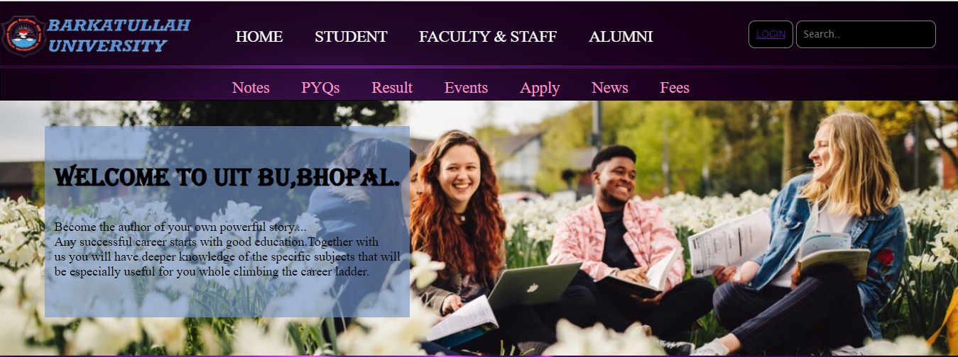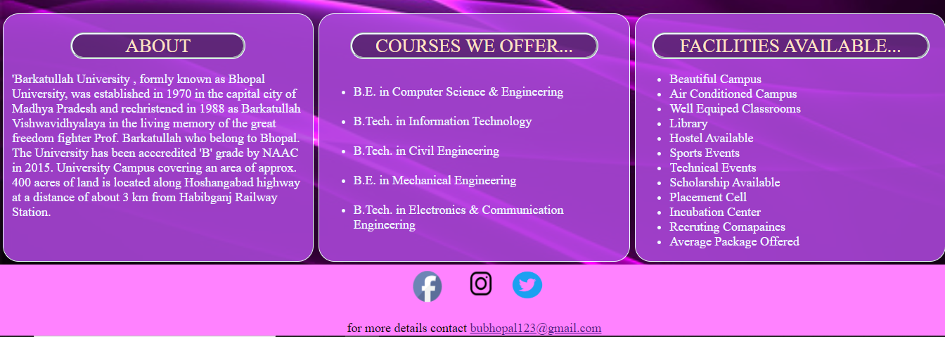

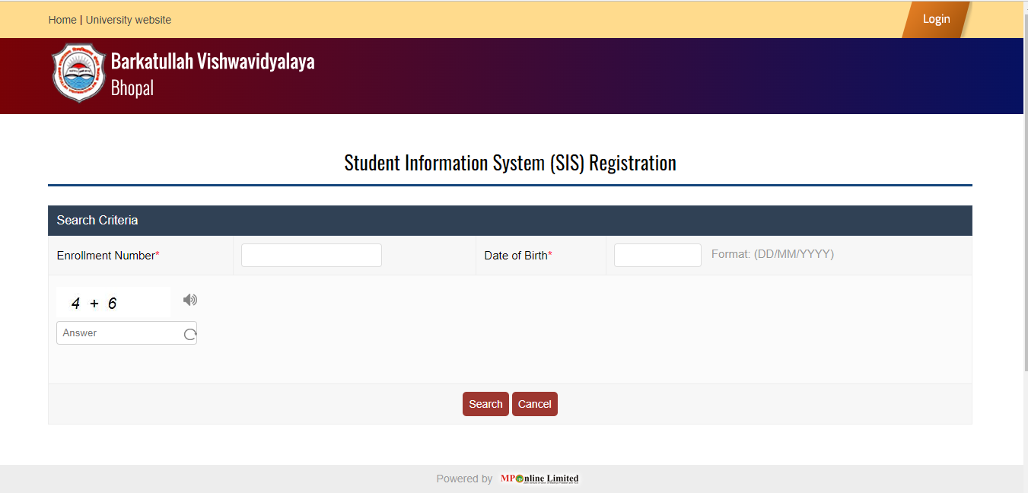

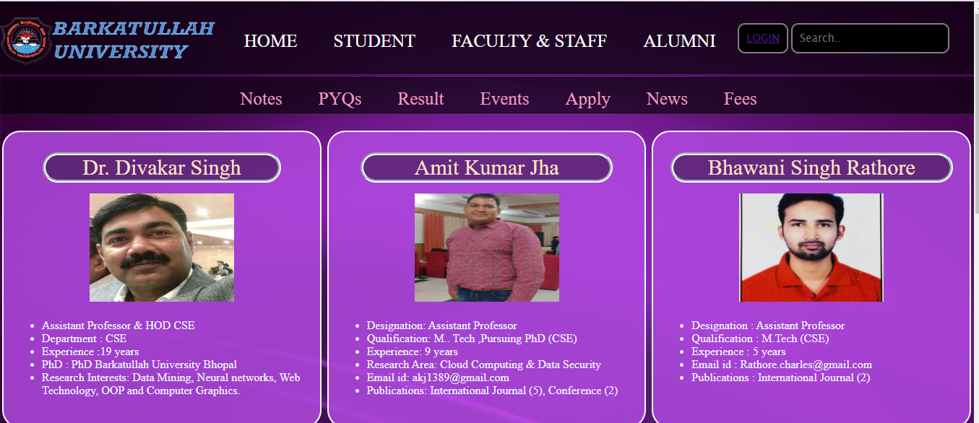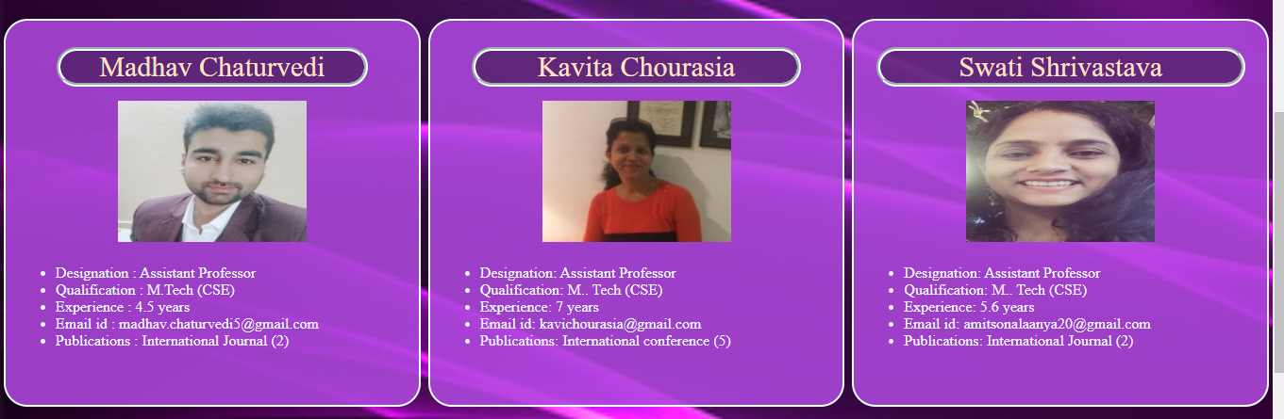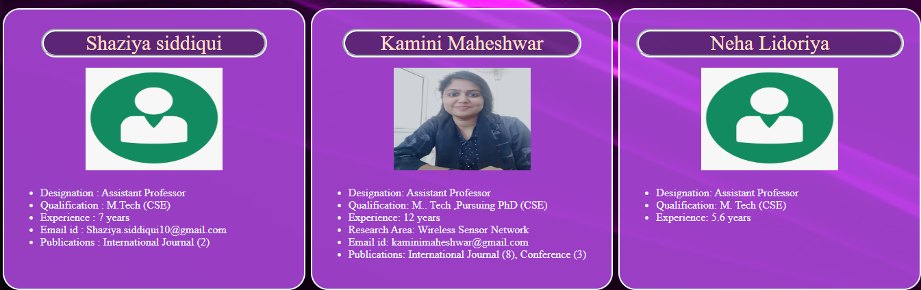

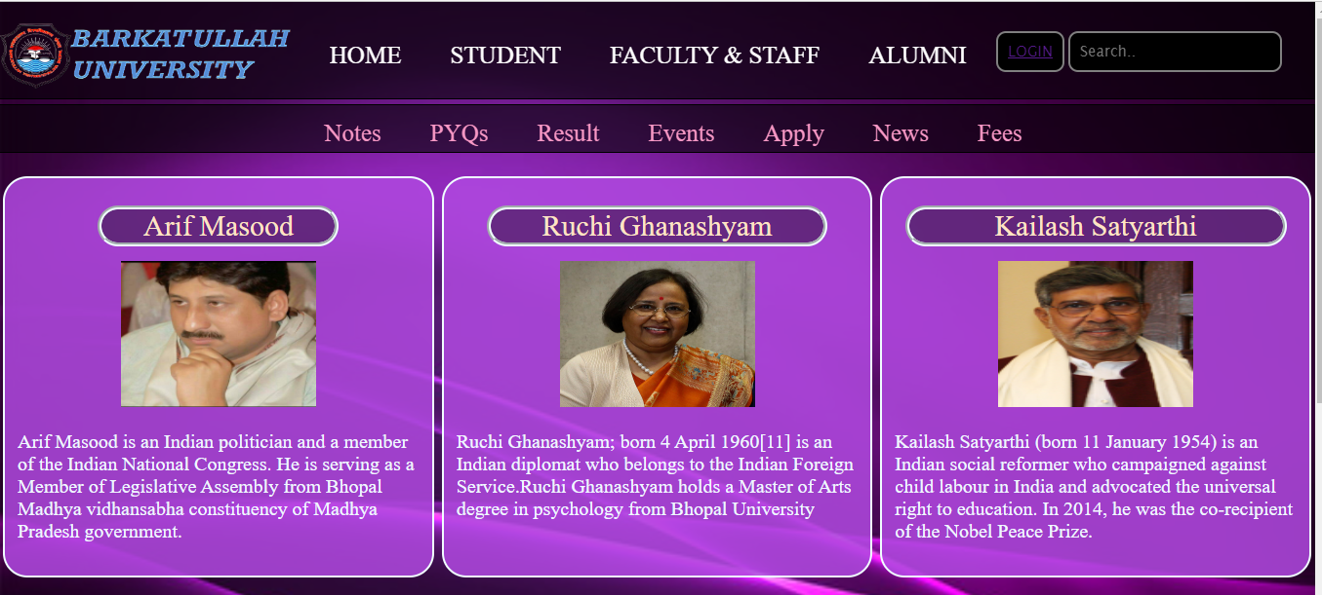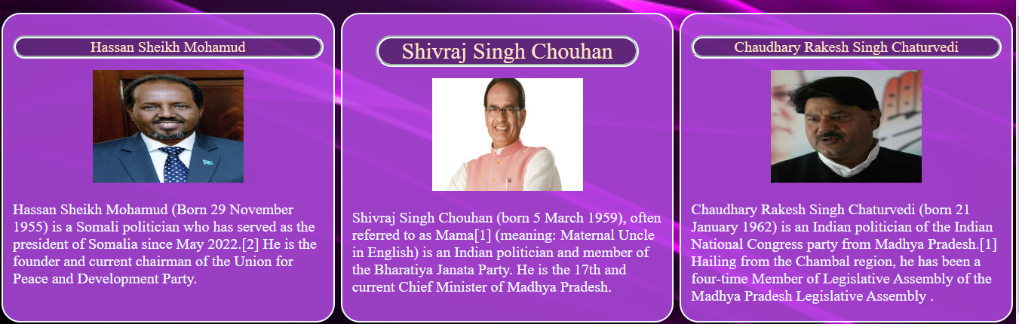

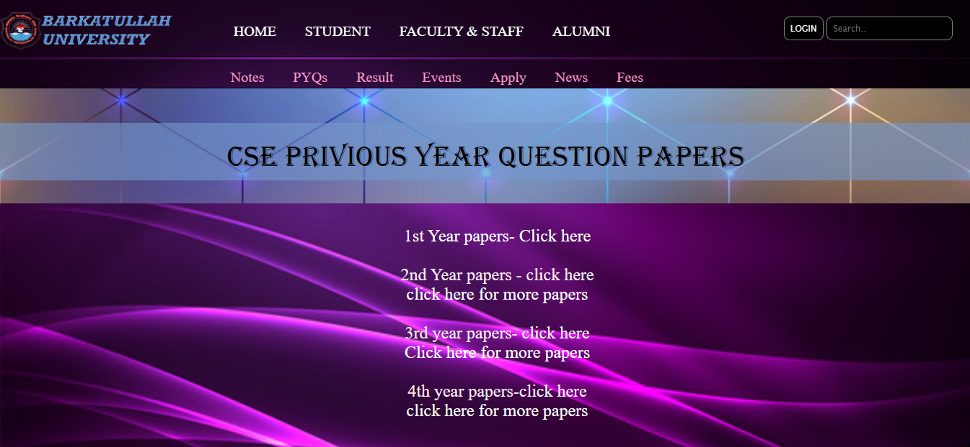

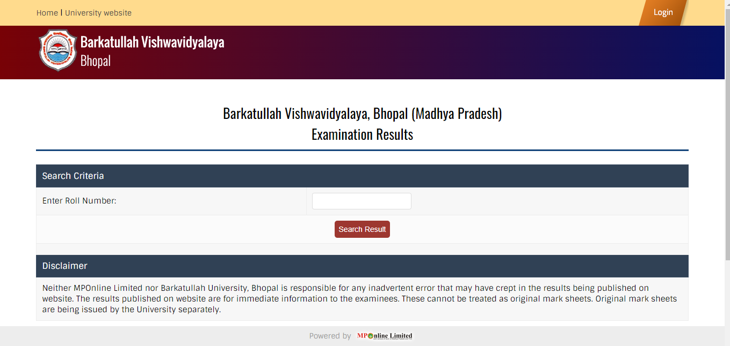

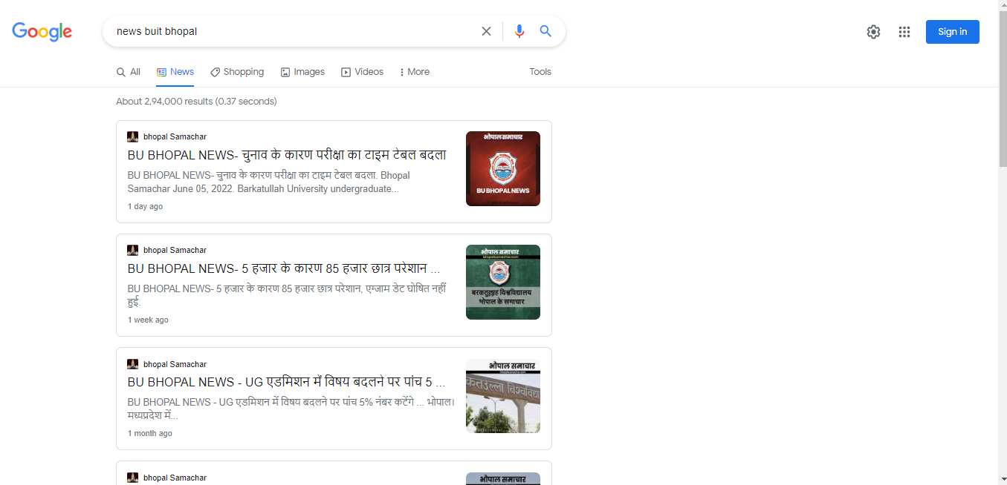

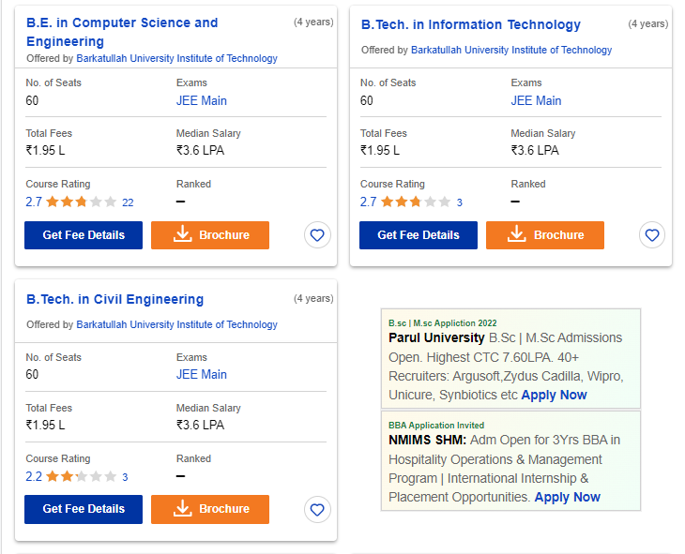

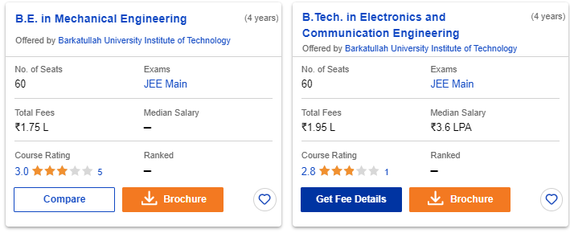

<!DOCTYPE html>

<html lang="en">

<head>

    <meta charset="UTF-8">

    <meta http-equiv="X-UA-Compatible" content="IE=edge">

    <meta name="viewport" content="width=device-width, initial-scale=1.0">

    <title>Home Pack</title>

    <link rel="stylesheet" href="style3.css">

    <link rel="preconnect" href="https://fonts.googleapis.com">

    <link rel="preconnect" href="https://fonts.gstatic.com" crossorigin>

    <link href="https://fonts.googleapis.com/css2?family=Fredericka+the+Great&display=swap" rel="stylesheet">

</head>

<body>

    <header class="header">

        <div class="left">

            <img src="logo-removebg-preview.png" height="70" width="300">

        </div>

        <div class="mid">

            <ul class="navbar">

                <li><a href="file:///E:/html/we_bsite.html#" target="_blank">HOME</a></li>

                <li><a href="https://bubhopal.mponline.gov.in/Portal/Services/BARKATULLAH/STUDENT_MGMT_SYS/Create_login.aspx"

                        target="_blank">STUDENT</a></li>

                <li><a href="file:///E:/html/faculty.html" target="_blank">FACULTY & STAFF</a></li>

                <li><a href="file:///E:/html/alumini.html" target="_blank">ALUMNI</a></li>

            </ul>

        </div>

        <div class="right">

            <button class="btn"><a href="file:///E:/html/login_page.html" target="_blank"></ahref>LOGIN</a></button>

            <input type="text" placeholder="Search.." class="btn">

        </div>

    </header>

    <div class="container">

        <ul class="navbar1" id="menuu">

            <li><a href="file:///E:/html/about.html" target="_blank">About Us</a></li>

            <li><a href="file:///E:/html/pyq.html" target="_blank">PYQs</a></li>

            <li><a href="https://bubhopal.mponline.gov.in/Portal/Services/BARKATULLAH/Counterbase/Result/VeiwResult.aspx"

                    target="_blank">Result</a></li>

            <li><a href="file:///E:/html/event.html" target="_blank">Events</a></li>

            <li><a href="file:///E:/html/reg.html" target="_blank">Registration</a></li>

            <li><a href="https://www.google.com/search?q=news+buit+bhopal&rlz=1C1RLNS_enIN1007IN1007&source=lnms&tbm=nws&sa=X&ved=2ahUKEwjIo_n2-pf4AhUNUGwGHSmAA68Q_AUoAXoECAEQAw&biw=1366&bih=625&dpr=1"

                    target="_blank">News</a></li>

            <li><a href="file:///E:/html/fees.html" target="_blank">Fees</a></li>

        </ul>

    </div>

    <div class="main_container">

        <div class="main">

            <p id="first">Welcome to UIT BU,BHOPAL.</p>

            <p id="second">Become the author of your own powerful story....<br>Any successful career starts with good

                education.Together with <br>us you will have deeper knowledge of the specific subjects that will <br>be

                especially useful for you whole climbing the career ladder.</p>

        </div>

    </div>

    <div class="container2">

        <div class="box">

            <p id="para1">ABOUT</p>

            <p id="third">'Barkatullah University , formly known as Bhopal University, was established in 1970 in the

                capital city of Madhya Pradesh and rechristened in 1988 as Barkatullah Vishwavidhyalaya in the living

                memory of the great freedom fighter Prof. Barkatullah who belong to Bhopal. The University has been

                acccredited 'B' grade by NAAC in 2015. University Campus covering an area of approx. 400 acres of land

                is located along Hoshangabad highway at a distance of about 3 km from Habibganj Railway Station.</p>

        </div>

        <div class="box">

            <p id="para2">COURSES WE OFFER...</p>

            <ul id="list1">

                <li>B.E. in Computer Science & Engineering</li><br>

                <li>B.Tech. in Information Technology</li><br>

                <li>B.Tech. in Civil Engineering</li><br>

                <li>B.E. in Mechanical Engineering</li><br>

                <li>B.Tech. in Electronics & Communication Engineering</li><br>

            </ul>

        </div>

        <div class="box">

            <p id="para3">FACILITIES AVAILABLE...</p>

            <ul id="list2">

                <li>Beautiful Campus</li>

                <li>Air Conditioned Campus</li>

                <li>Well Equiped Classrooms</li>

                <li>Library</li>

                <li>Hostel Available</li>

                <li>Sports Events</li>

                <li>Technical Events</li>

                <li>Scholarship Available</li>

                <li>Placement Cell</li>

                <li>Incubation Center</li>

                <li>Recruting Comapaines</li>

                <li>Average Package Offered</li>

            </ul>

        </div>

    </div>

    <section class="footer">

        <div class="social">

            <a href="https://www.facebook.com/BarkatullahUniversity/" target="_blank"><img

                    src="images-removebg-preview.png" width="80" height="50"></i></a>

            <a href="https://www.instagram.com/bubhopalstudents/?hl=en" target="_blank"><img

                    src="instagram-icon-png-transparent-instagram-icon-images-884866-removebg-preview.png" width="80"

                    height="60"></a>

            <a href="https://www.youtube.com/" target="_blank"><img

                    src="twitter-icon-transparent-11549680383mmzgiol88v-removebg-preview.png" width="60"

                    height="55"></a>

        </div>

        <div class="social2">

            for more details contact <a href="uit_barkatullah@bubhopal.ac.in   "> uit_barkatullah@bubhopal.ac.in

                <br> Contact Number: 07554726006

            </a>

        </div>

    </section>

</body>

</html>